Ngaire Shepherd-Wills
Teach NZ Sabbatical Project
Term 2, 2013.

Sabbatical Topic:

What impact does a modern learning environment have on pedagogical practice and student learning experiences?
- What is a Modern Learning Environment (MLE) and how does it support the New Zealand Curriculum?(Research)
- What pedagogical changes are required to teach effectively within a MLE? (Research)
- What impact does a MLE have on student learning experiences and how does this impact achievement and engagement? (Research)
- What are the experiences of teachers and students who have transitioned from a traditional classroom setting to an MLE? (Interviews/Observations)
- What key elements of professional development are required to support and sustain a change of practice? (Research/ Findings and recommendations.)

Acknowledgements:

I would like to thank the Ministry of Education for the opportunity to take a teaching sabbatical this year. It has been a great opportunity to explore a topic of particular interest to me and to reflect on my teaching practice.

I would especially like to thank the Board of Trustees, Principal, Leadership Team and Staff at Clearview Primary for their support over the past term.

Many people gave very generously of their time, resources and expertise and I am very grateful for this. I would like to acknowledge the following schools and people:

Stonefields School, Auckland.
Elim Christian College, Auckland.
St Kentigerns School, Auckland.
Clarkville School, Canterbury.
Lyttleton West School, Christchurch.
Waimairi School, Christchurch.
Breens Intermediate, Christchurch.
Linwood North School, Christchurch.
Peter Vause, Ministry of Education.
Chris Bradbeer, Stonefields School.
Pene Abbie, Clarkville School.
Meredith Devonald, Linwood North School.
Brian Price, Breens Intermediate School.
Mike Anderson, Waimairi Primary School.

Background and Rationale:

I am a teacher in a newly built primary school. Clearview Primary is located in Rolleston, Canterbury. It opened in 2010 with 170 pupils. By 2013, the roll had grown to 540 pupils and a new 12 class space was opened to support that growth. The classroom environments meet the Modern Learning Environment (MLE) criteria outlined by the Ministry of Education.

In 2012, our staff began exploring ways in which we would need to change and adapt our teaching practice to respond to the environments in which we were teaching. Around this time, major decisions about the future of education in Canterbury due to the recent Christchurch Earthquake were being made by the Ministry of Education, with many schools in our area requiring rebuilding, repairing or significant redevelopment. These projects will need to meet MLE criteria.

I became interested in how teachers and students will transition from a traditional learning environment into a modern learning environment. I wanted to identify what supports would be required and how schools could effectively manage this transition. Some literature refers to “Better Learning Environments (BLE) or Innovative Learning Environments (ILE). I have used the term Modern Learning Environment (MLE) as this is the standard term used by the Ministry of Education in New Zealand.

Methodology:

I began by spending time reading journal articles and reports about Modern Learning Environments and their relationship to student achievement.

I read online blogs by teachers, educators and designers that work with Modern Learning Environments.

I attended the CEFPI (Council for Educational Facilities Planning International) Australasian Conference in Auckland, New Zealand. (June 2013)
I visited a range of new schools in Auckland as part of the conference and also on visits in 2012, as part of my school’s professional development programme.

I spent time observing teaching and learning at Clearview Primary, Rolleston. I talked with teachers and students about their experiences in these environments.

I visited a range of schools in Canterbury. I tried to visit schools with various decile levels, types of buildings, age ranges and pedagogical approaches.

I attended the Core Education MLE expo. (June 2013)

I developed an online resource where I blogged about my experiences visiting schools and shared online resources that I found valuable. It helped to record my thoughts and reflections and develop the direction for this project. I hope that this will be a tool for teachers in New Zealand, and especially in Canterbury, as they transition to MLE’s.
http://mlenewzealand.weebly.com

I developed a survey for teachers and students that I sent to primary schools opened since 2010 and schools that participated in the Learning Studio Pilot Programme.

Findings:

- What is a Modern Learning Environment (MLE) and how does it support the New Zealand Curriculum?
In New Zealand, a MLE is a term used to describe buildings that meet a set of criteria developed by the Ministry of Education. That criteria is listed here. The Ministry identifies core features of an environment – this includes items such as lighting, heating, acoustics, technology accessibility and ventilation. Some buildings, including all new school spaces built in New Zealand, meet moderate and advanced MLE criteria. This includes items such as flexible spaces and outdoor areas. “Modern Learning” is the term used by the New Zealand Ministry of Education. Some countries use the term “Better Learning Environments” or “Innovative Learning Environments.”

Core Education provides an excellent definition of a MLE:

“An opportunity to design and build a modern learning environment is an opportunity to create spaces fit for 21st century learners. As much as it’s about buildings and furnishings, it’s about creating spaces that promote
learning that is personalised, student-centred, engaging and connected to real problems and the real world”.

“Modern learning environments can help create the environment, mindsets and human capacity to help our young people make the most of their talents on the local and global stage. For them to be confident and capable to lead change, be creative, innovative and, above all, great citizens.” (Core Education, 2013, Modern Learning Environment Expo, retrieved July 1, 2013.)

The New Zealand Curriculum (2007) outlines the vision of “young people who will be confident, connected, active, lifelong learners.” The principles of learning to learn, inclusion, community engagement and future focus are also supported by a modern learning environment. Values such as ecological sustainability and innovation and the key competencies are also given scope for development. A MLE provides opportunities for students to participate and contribute, be self-managing and relate to others. (Ministry of Education (2007) The New Zealand Curriculum.)

It is interesting to note that some of the schools I visited, while not new, were adapting their traditional environments to a more modern learning environment. This may have been done by changing space, replacing furniture or implementing different pedagogies, but upon discussion with teachers and principals, the intention was to better meet student’s needs and the demands of the New Zealand curriculum.

You can read my blog post titled “What is a Modern Learning Environment?” here.

What impact does a MLE have on student learning experiences and how does this impact achievement and engagement?

What are the experiences of teachers and students who have transitioned from a traditional classroom setting to an MLE?

From my visits to schools and discussions with students learning in a MLE, students report more ownership, choice and individuality with their learning. Studies show that students and teachers report higher levels of engagement in a MLE and there are links to increased student performance (Wall, 2013., Tanner, 2008., Blackmore et al, 2011).

One school I visited reported that behaviour incidents had decreased substantially as they introduced more personalised learning and changed the classroom environments.

The relationships between environment and people are complex. Research commissioned by the Education Department, State of Victoria, Australia noted
“Poorly designed and maintained schools, often found in areas of lowest educational achievement, can also have a detrimental impact on teacher and student morale and engagement, and impact negatively on aggregate student outcomes (Filardo, 2008). Collectively, these factors impact on teachers’ work, attitudes and behaviours, and in turn have flow on effects on student learning.” (Blackmore, J., Bateman, D.,Loughlin J., O’Mara, J., & Aranda, G. (2011) Research into the connection between built learning spaces and student outcomes. Melbourne, Australia: Education Policy and Research Division: Department of Education and Early Childhood Development.
From the survey I conducted with students there were 82 responses. The students were asked about learning opportunities in their schools and their preferred learning environment.

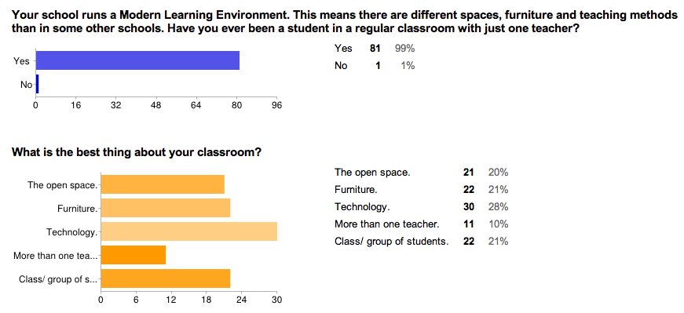

Students identified technology as the best thing about their classrooms. Furniture, open space and class members were closely second. Ten percent identified having more than one teacher as their highlight of learning in a MLE.
When examining learning opportunities, most students felt they had choices with what they were learning, where and with whom they worked. Many had opportunities for individualized learning, using pathways and progressions. Students identified a high level of opportunity to share learning with family.
Although students identified technology as their favourite thing about working in a MLE, there was not a large number that were able to use technology whenever they needed it, and opportunities for them to share learning online were lower than being able to view online resources to support learning. It would be interesting to pursue reasons for this, to find out if this is an issue of resourcing, or if control of the technology still lies with the teacher.

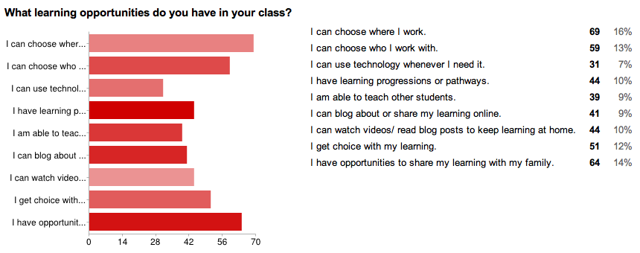

When asked which type of learning environment was preferable, 80 % of students identified a MLE as opposed to a single cell classroom. Reasons for this included:
“Because if one teacher is busy you can go to the other teacher.”
“I prefer the modern learning environment because you can choose where you want to work and can also choose to work alone or with mates (as long as you stay on task!!!!!!!)”
“ We get more opportunities.”
“Because having three teachers lets you experience different teaching styles and it is good to have a healthy relationship with different teachers.”
“I prefer the Modern Learning Environment because we get to share spaces and that we can meet new friends if you don’t know that person. You can work where you want to and you get to sit on furniture.”
“ We are allowed to use our devices for learning.”
“The furniture is really comfy and cool. I love this environment.”
Comments that demonstrated preference for a single cell classroom, usually related to noise and distraction.
“ In old classrooms it’s not as noisy.”
“I prefer my old classroom because there is too much noise in the environment and I always get distracted.”
When students were asked what their greatest challenges were for their transition, they reported that staying on task and not getting distracted was difficult for them, followed by noise. Many of the students I spoke to commented that their new environment was noisy and they were often looked for a space where it would be quieter. The flexibility of space, or use of “rooms within rooms” was identified by many students that I spoke with.

An experiment where privacy booths were set up in the classroom had interesting results. “Using ‘booths’ set up for privacy in the classroom, Ahrentzen and Evans (1984) sought to examine the environmental features of elementary school in relation to distraction and privacy. They found that when children wanted to be alone, they prefer to be in secluded study areas or corners, rather than the total privacy of the booth, while maintaining visual contact with others.” Blackmore et al. (2011)
An example of student desire to create smaller spaces was demonstrated in the planning for a second stage build at Stonefields School in Auckland. After extensive consultation, student feedback indicated that smaller, flexible spaces were desirable. You can read about that consultation here. (Bradbeer, Chris (2013, March 10) “Open Learning Spaces…and the smaller spaces within.” Retrieved June 2013.

The key difference in a MLE, is that spaces within an open space still allow for transparency and visibility. Students and teachers working within the spaces are still part of the wider space. Stephen Heppel describes these places; “they offer a space for mutuality, for an intimacy of collaboration, for serious study and focused conversations, for peace & quiet sometimes, for focus and of course, with always one side open.” (Heppel, Stephen (2013) “Rooms within Rooms”. Retrieved June 2013.) an eye line in, for safety too

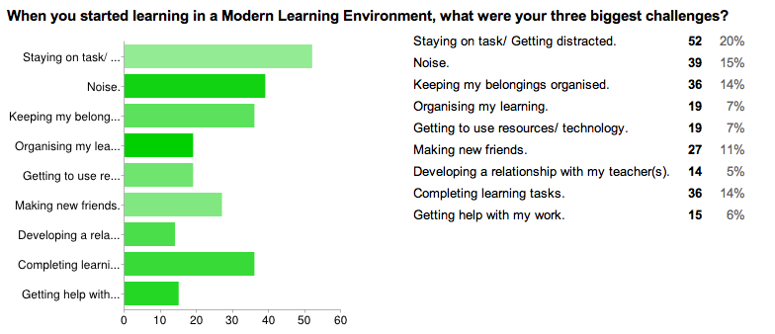

Students were asked what advice they would give to fellow students making the transition to a modern learning environment.
“You need to be able to be independent.”
“Put your name on everything.”
“Try your best. It’s much noisier but you can make new friends by being yourself.”
“There’s a lot more opportunities, so don’t hold back when it comes to stepping up.”
“Don’t freak out.”
“If you listen, follow the rules etc, you will find this modern learning environment is amazing.”
“Keep the noise level down because others can hear you, choose your space carefully so that you don`t disturb others, keep your stuff labeled so that you don't lose your stuff in the big learning environment. P.S-don’t leave your stuff on the floor.”
“There are often a lot of changes in the new learning environment so don't always get so hooked with that certain space because you will change your work space almost everyday! Its not hard working with more than 1 teacher. It is fun!”
“When moving into the M.L.E it would be really cool to be able to bring in your own technology because it is more practical.”
“When you are about to get a new learning environment just think of what you can do. You will be able to make heaps of new friends and you will be able to work where you want to. When you get a new learning environment, just keep your head up high and think about positive things. I think the people that get a new learning environment will love it and they will be able to do stuff they couldn't do when they had a regular classroom.”
“Be prepared for a new environment. It’s a lot different from your old normal classroom. Listen carefully to your teachers because it can get very confusing. Look after your belongings and look after your peers and look after good friends. Take all opportunities available to you and give everything a go.”

What are the experiences of teachers and students who have transitioned from a traditional classroom setting to an MLE?
What pedagogical changes are required to teach effectively within a MLE?

It became evident early on in my research, that there are many factors and variables that are influencing change in education today. The availability of technology, furniture solutions, modern learning environments and curriculum design are all having an impact on the future direction of schools.

There is evidence that changes to pedagogy are required to make effective use of modern teaching spaces. There is also evidence that these changes cannot happen without significant support and professional development.

“Literature indicates teachers enjoy novel spaces, and are usually encouraged to experiment with student organization (e.g. individual, groups, whole class) within specific types of physical spaces. Yet there is little recognition of the preparation required for teachers and students to effectively transition into using new learning spaces in terms of pedagogies, as well as setting realistic expectations and contingency planning. If teachers are not well prepared and given leeway for risk taking and failure, particularly if disruption is ongoing, they may revert to ‘default pedagogies’ or ‘the way we used to do things’ rather than explore innovative pedagogies (Thomson, 2009)(Blackmore, J., et al (2011).
In terms of effective pedagogy, I felt that there is already much information available about this in the New Zealand curriculum, Best Evidence Synthesis and John Hattie’s work. So I chose to focus more on the support to implement effective pedagogies.
In my discussions with principals, leaders and teachers, there was often concern expressed about feeling ill prepared for the transition to a MLE. Teachers often mentioned looking for information, but finding it difficult to access.
In the survey I conducted with teachers, I received 35 responses. The survey was sent to a selected group of schools. It is important to note that the results are based on teacher’s perceptions and personal experiences.
Teachers were asked about their experience in teaching spaces, their curriculum design and to identify their three greatest positives and challenges, when they transitioned to a MLE.

All teachers in the survey had taught in a single cell classroom, prior to transitioning to a MLE, with a range of teaching experience.

The majority of teaching spaces were described as open spaces with flexible learning areas, or classrooms with learning studios. This is because the survey was sent to schools that participated in the Learning Studio Pilot, or schools that have opened since 2010. These schools will meet advanced MLE criteria.
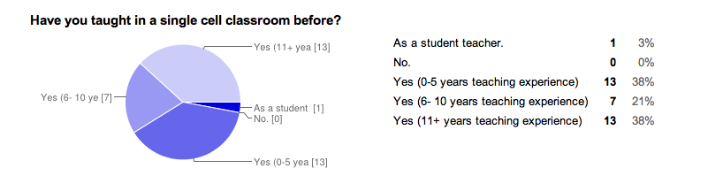
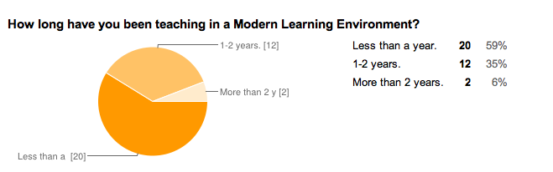
Teachers were asked to identify their three greatest challenges when they transitioned into a MLE. One could argue that this transition is ongoing, as the majority of teachers have been teaching in a MLE less than a year.
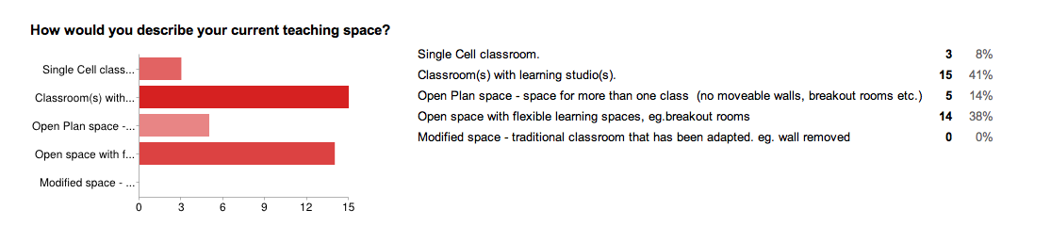
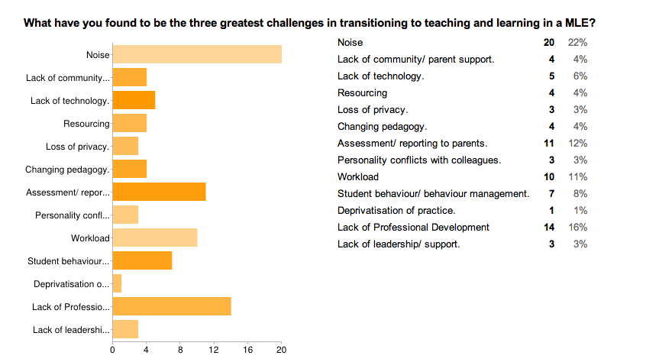
Teachers overwhelmingly identified noise as the biggest challenge they faced. This was followed by lack of professional development and assessment and reporting to parents.

From my conversations with teachers, noise is definitely a distraction and source of frustration for teachers. Gabrielle Wall, (Ministry of Education) found that “…most studies list the negative outcomes of poor acoustics in terms of student health or engagement outcomes, and indirectly infer their evidence on student achievement (Higgins et al., 2005; Schneider, 2002). As more direct relationships with achievement, studies suggest that poor acoustic quality impairs performance by causing students to miss or misinterpret part of the teacher’s lesson and may tune out altogether if this occurs too frequently (Johnson, 2001). One study found that teacher pauses during bursts of external noise could lead to a reduction in teaching time of up to 11%( Rivlin & Weinstein, 1984). Reviews of teacher outcomes show that poor acoustic quality can lead to adverse effects for teachers also, including annoyance, less patience, less inclination to repeat information, and increased fatigue (Morris Jr, 2003; Tanner, 2000). A study comparing the two groups found that external noise was more disruptive for teachers than for students (Lucas, 1981). (Wall, Gabrielle, (2013, June) Review of the impact of Modern Learning Environments on student achievement and engagement outcomes.

It is interesting that both teachers and students identified noise as a challenge in a Modern Learning Environment and this would indicate that there is room for improvement in acoustics, as well as scope for changes in behaviours, the set up of the environment and manipulation of spaces.

Many teachers commented on the survey about professional development prior to their transition. Some had been able to visit other schools and be involved in learning opportunities. Some felt ill prepared and some had not been offered professional development.

“Visiting other MLE environments around NZ was beneficial, being able to chat to teachers who were using such an environment. Would have liked to have more professional readings and whole staff conversations unpacking pedagogy and how we might do things.”

“I received no professional learning prior to teaching in this manner, apart from being told about it by a leadership team member who had observed in MLEs.”

“We opted to participate in PD about student centred practice and individualizing programmes.”

“I had no professional development specific to this transition, but was already working in a team teaching situation.”

“Some anecdotal information from colleagues who had visited other schools. Nothing else.”

Assessment and reporting to parents was also identified as a challenge. This is probably due to changes in pedagogy – for example, in a team teaching situation there will be different requirements for assessment and reporting. Some teachers felt that changes to reporting and assessment were not keeping pace with changes to teaching and learning.

“Doing reports and finding out information about my students has been very time consuming and challenging.”

“In a team teaching situation, I feel I am not getting to know my students to the same in depth level as before. This is making assessment and reporting challenging, as I know a little bit about a lot of students, not a lot about some students.”

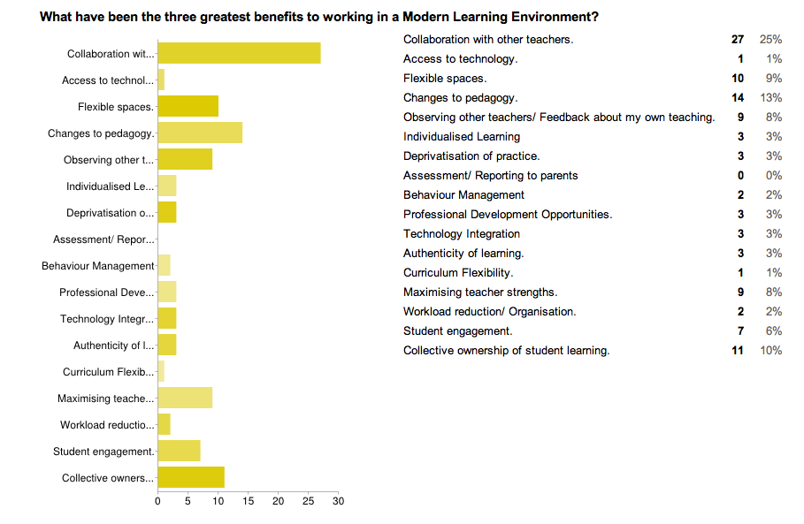
Teachers were asked what the three greatest benefits to working in a MLE have been.
Teachers identified collaboration with other teachers, changes to pedagogy and collective ownership of student learning as the three greatest benefits.
Many schools that operate Modern Learning Environments have made significant changes to the ways classrooms operate. Traditional single cell classrooms with one teacher have made way for open teaching spaces, team and collaborative teaching and flexible learning opportunities. In the past, teachers have often noted the isolation that can come with teaching in a single cell classroom as the sole practitioner.
Blackmore et al found that “Collaboration and team teaching is, from the professional learning literature, likely to lead to improved student outcomes (e.g. Darling-Hammond, 2002), but only with significant teacher professional development and supportive school cultures. Collaboration is not without issues — loss of autonomy, tension over work allocation, greater communication and interdependence among teachers and responsibility to others (York-Barr, Ghere & Sommerness, 2007). Overall, in York-Barr et al. (2007), the teachers felt that the advantages of team teaching outweighed the disadvantages. They cited inter-disciplinary, opportunity to pool insights about individual student’s learning and personal qualities gained from longer periods of contact as significant positive factors.
From my survey, teachers do have concerns about being forced to collaborate with a teacher whom they find difficult to work with. There were also concerns about scheduling and time to collaborate. However, the fact that teachers identify collaboration as their number one benefit would indicate positive outcomes when issues can be worked through.
“Getting three or four people together to plan is becoming quite difficult. This has meant that a lot of things are not planned to the last minute and that is not the way I like to teach.”
“Some teachers say that team teaching would not suit them and that they couldn’t work with some people. I think that it is a matter of learning how to work in this way and that PD about how to work collaboratively needs to be available.”
“I have been lucky enough to work with colleagues that I get along and work well with. I would be worried that in the future that might not be the case and how this might impact on my teaching and enjoyment at work.”
“Challenges: Getting everyone on board. Managing time with other teachers personal commitments affecting when and how often you can meet. Knowing where to start when it comes to planning workshops in terms of timing, best practice and assessment. Benefits: able to target more needs within the class, streamlined planning (eventually), collaboration with colleagues, teaching to strengths, professional conversations about assessment of students, sharing of resources.”
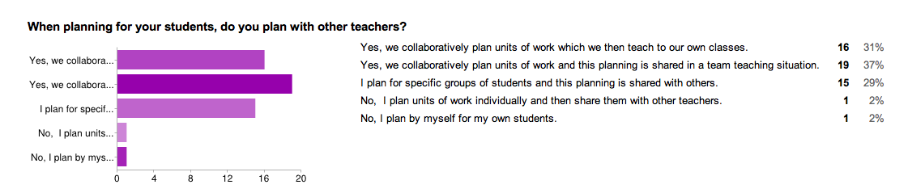
Further survey questions indicated high levels of collaborative and shared planning, although most schools still operated a semi- traditional curriculum design.
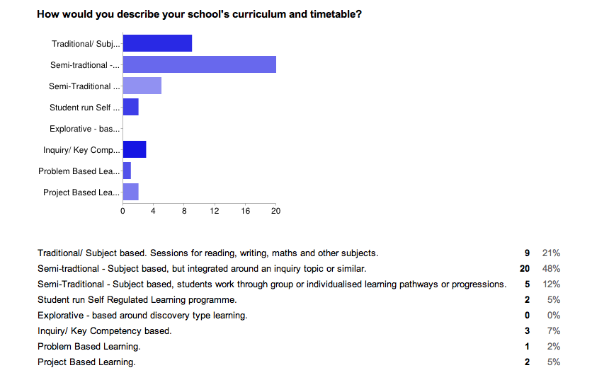

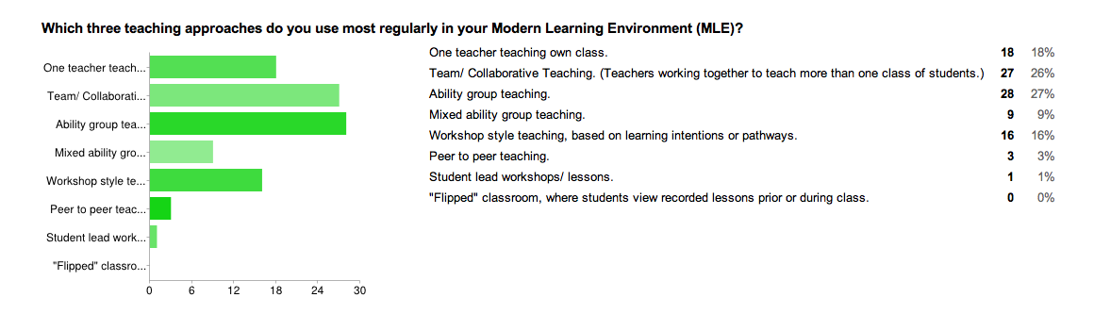
- What key elements of professional development are required to support and sustain a change of practice? (Research/ Findings and recommendations.)
In my survey, teachers were asked to identify key support elements that they perceived as important to a successful transition to working in a MLE. Teachers ranked an understanding of effective pedagogy as most important, closely followed by time to prepare, organize and collaborate, professional development and supportive colleagues.

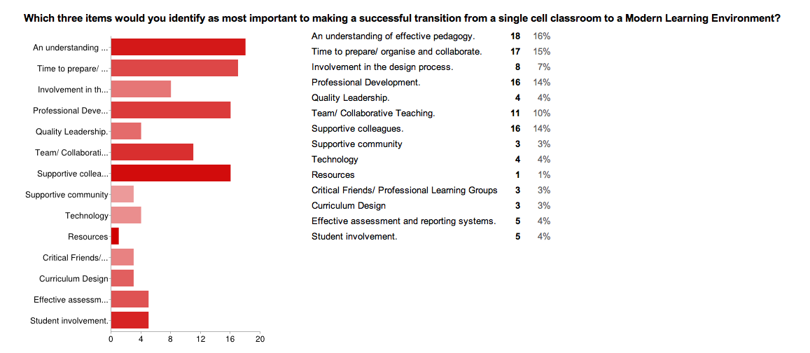

Recommendations/ Findings:
The following recommendations are based on my term of observations, reading, talking to experts and school leaders and surveying teachers and students in new schools. They also draw on my fourteen years of teaching experience in three different countries as well as time spent teaching collaboratively and in a MLE.
The transition to teaching and learning in a MLE is ongoing and will continue to evolve.
Students:
Where possible, students should play an active role in the design of a new learning space. They should participate in planning for their transition to a new space.
Students need explicit teaching as they transition to a new learning space. For example, students who are used to sitting at the same desk all the time, may not find it natural to choose a different space to work in. New routines and ways of learning may need to be developed. Students may try and “own” an area in the MLE.
Students need a clear understanding of who they are as a learner. This may come from work the school has done around their values and vision. They need the vocabulary to be able to talk about their learning. Michael Absolum’s work in “ Clarity in the Classroom”, provides some great ideas and scaffolds for this.
There is wide scope for the development of the key competencies and curriculum principles during the transition to a MLE.
Ongoing evaluation and reflection is vital, in order to adapt to the new environment in a positive way. Of importance is how inclusive the new environment is.
New students that arrive during the school year, need support to transition to the new environment, depending on their prior learning experiences.
Students have the opportunity to use the MLE and technology to participate in personalised learning pathways. They need to become the drivers of their own learning.

Teachers:
If at all possible, teachers need to participate in the design process.
“This trend towards participatory decision-making is mirrored in the research literature on school improvement with closer attention being paid to listening to teachers and students (Thomson, 2009). The input of teachers in design is said to be critical (Temple, 2007; Higgins et al., 2005; Sanoff, 1995) because staff morale (Higgins et al., 2005) and teacher attitudes and behaviours affect the use of space and learning outcomes. Their lack of involvement could lead to a negative orientation to new spaces (Temple, 2007; Fisher, 2002; Wolff, 2008). Participation in the design process and investment in their environment, Loi (2006) argues, indicates to teachers they are valued. Moreover, the prospect of a new environment heightened through participation will motivate teachers.” (Morgan, 2000; Oblinger, 2005; Temple, 2007).
Teachers need an understanding of current learning theory and effective pedagogy. They need to understand that for the first time, technology has enabled us to reach a point where education can become truly personalized. The modern learning space will support the development of this.
“A pedagogical repertoire based on personalisation ranges from individual computer-based instruction to basic skill acquisition through to individual learning plans, e-portfolios and mapping pathways (Jenkins & Keefe, 2001). Strategies of personalised learning include multimodal approaches to teaching and flexibility in classroom settings conducive to learner-centred and project-based interdisciplinary pedagogies. Some examples of this include individual computer assisted skills learning, learning-style-based instruction, self-paced learning, contract learning, guided practice through coaching, co-operative learning in small groups and project based or topic study.”
Effective leadership is vital to supporting teachers, students and the community during the transition to a MLE. Quality professional development needs to be provided for all staff, implemented using an appropriate change model. Parents and stake holders need to be informed and be part of the change process. It is vital that leadership creates a safe environment where innovation is encouraged and risk taking, experimentation and failure are allowed.
Teachers need time for collaboration, reflection and evaluation. They need to have a shared vision of 21st century teaching and learning. There needs to be clear expectations for them. Norms for teachers should be developed, to provide a scaffold should “courageous conversations” need to take place at any stage.
A school’s curriculum design must enrich the pedagogies being implemented and the teaching and learning spaces.
The school’s systems must support, not hinder. For example, the school day, teaching teams, timetables and schedules need to be critically examined to ensure they are enhancing the school’s teaching and learning programmes. It is an opportune time to question the way “things have always been done” and innovate to make improvements.
Designers and educators will need to work together, remembering that function is more important than form. Architects and designers need to provide the ideas and inspiration to imagine new futures, while educators provide the expert knowledge about purpose.
Colleges of Education will need to adapt their teacher training programmes and requirements.
The process of transition will take time and go through several phases. Firstly the initial “Why?” phase, where teachers need to see the value, reasoning and research behind the changes that they will be required to make to their teaching practice. This is followed by the “How?” phase, where teachers need time to work out the details, systems, routine and programme. This is the phase where there should be time allowed for experimentation, innovation, questioning, mistakes and constant reflection. Finally, the “What?” phase, where the focus should fall on the teaching and learning that is happening in the classroom.

Conclusion:
This is an exciting time to be an educator. In New Zealand there is significant opportunities for development and innovation, in part as a result of the Canterbury Earthquakes, but also due to leaky building replacements and the ageing property portfolio in our schools.
As Stephen Heppell said at a recent Canterbury event; “Be brave enough to build the schools of the future. Now is the time for innovation.” (Core MLE Expo, June, 2013.) There will be many opportunities in the next ten years to create better, innovative, modern learning environments. It will be vital that leaders at every level of education are well informed, ready to lead change and future focused, in order to transform our education system.

Key References:
Blackmore, J., Bateman, D., Loughlin, J., O’Mara, J., & Aranda, G. (2011) Research into the connection between built learning spaces and student outcomes. Melbourne, Australia: Education Policy and Research Division: Department of Education and Early Childhood Development.

BRANZ Ltd. (2007) a-d Designing Quality Learning Spaces (Acoustics, Heating and Insulation, Lighting, Ventilation and Indoor Air Quality: Ministry of Education.

Clark, H. (2002) Building education: the role of the physical environment in enhancing teaching and learning – issues in practice. London: Institute of Education.

Higgins, S., Hall, E., Wall, K., Woolner, P., &McCaughey, C. (2005) The impact of school environments: A literature review. The Centre for Learning and Teaching, School of Education, Communication and Language Science, University of Newcastle.

Ministry of Education (2012) Learning Studio Pilot Review Ministry of Education

Ministry of Education (2011) New Zealand School Property Strategy 2011-2021. Ministry of Education

Wall, Gabrielle., (2013) Review of the impact of Modern Learning Environments on student achievement and engagement outcomes. Ministry of Education.
Web Resources:
http:mlenewzealand.weebly.com http://www.heppell.net http://openlearningspaces.blogspot.co.nz http://thethirdteacherplus.com http://canterburyplgmle.blogspot.co.nz

